# Competitor 1: Cyber Challenge (https://www.cyberchallenge.com.au)

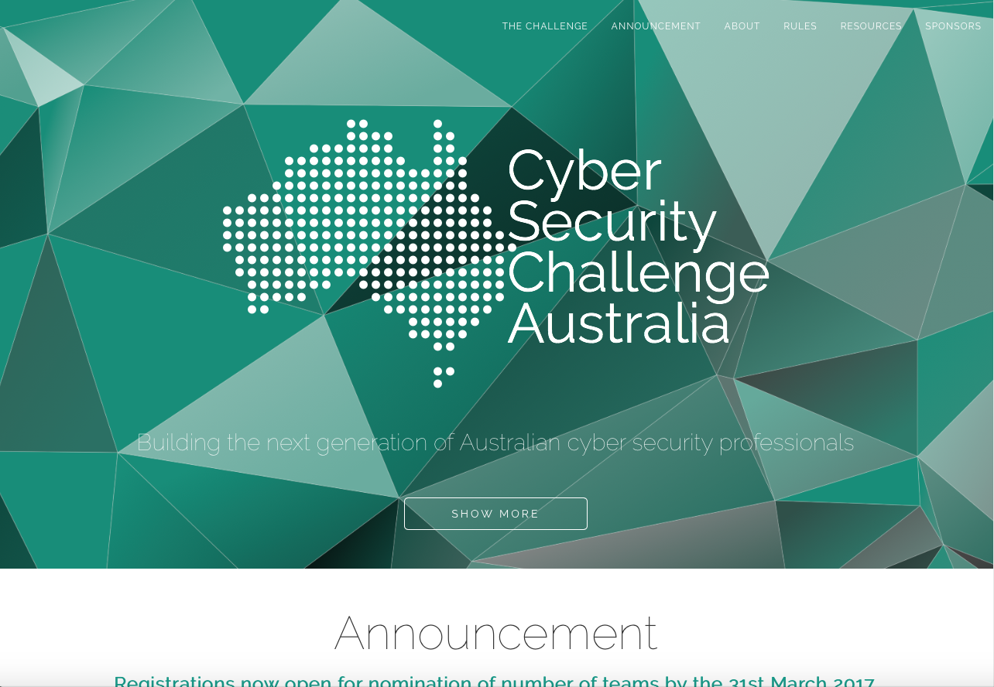

Cyber Challenge Home Page

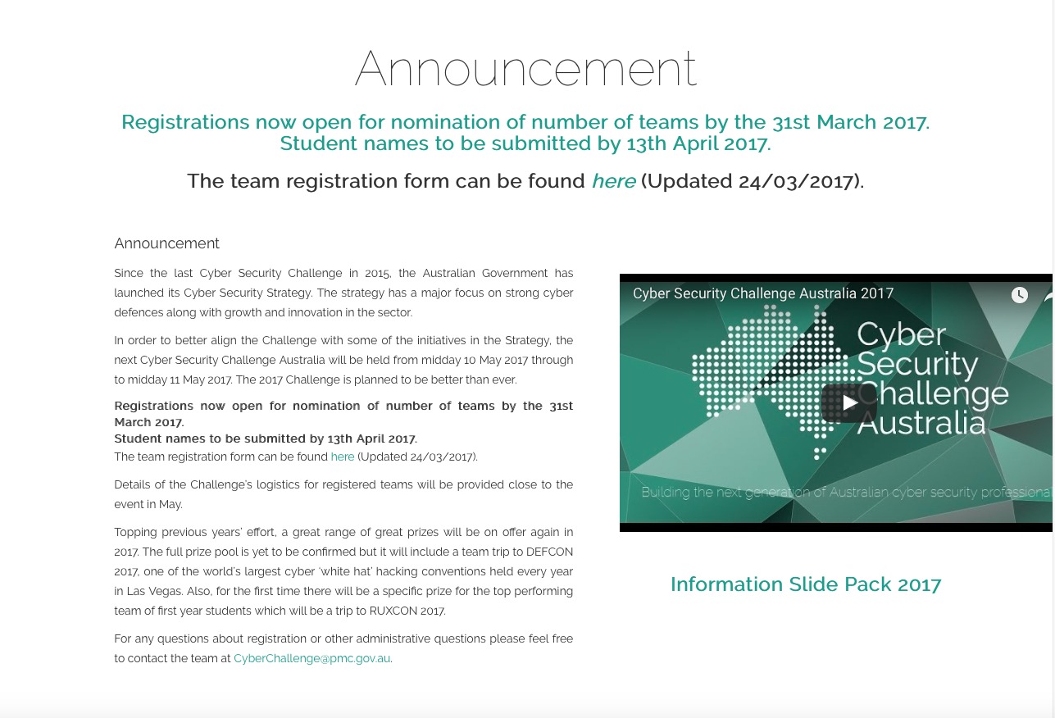

Cyber Challenge Sub Section (Page)

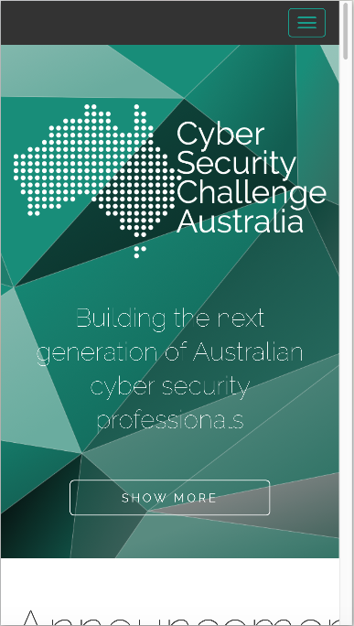

Cyber Challenge Mobile View (iPhone 6s)

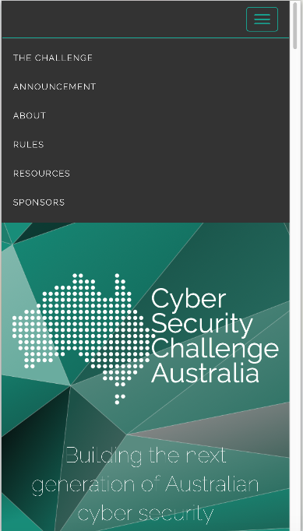

Cyber Challenge Mobile View with menu (iPhone 6s)

## Content/Functionality

Cyber Security Challenge Australia is a single page flyer site for the advertising of a hacking challenge presented by the government. The overall design is simple and appears to have all information available simply.

Specific content/function is listed in terms of analysis:

#### Information Offered:

* “Poster” home page
* Announcement – overall details and where to get extra information
  + Video
  + Registration form
* The Challenge – What the challenge entails and how it came about
* Rules and eligibility
* Terms and Conditions
* Privacy Statement
* Resources
  + Past results
  + Solutions
  + Prizes
* Sponsors
  + Links to sponsors

#### Technology Used:

* HTML5 and CSS3
* Bootstrap
* JQuery for animation and DOM manipulation
* Google Fonts
* Cookies for tracking (used with analytics)
* Google Analytics
* YouTube video
* Local storage and session storage for YouTube embedded video
* Word and PDF forms
* Email addresses in page

#### Search Functionality:

* None

## Strengths

The greatest strength of this site is the well laid out information, easily findable and hard to get lost.

#### Specific strength include:

* Responsive, mobile first design
* Main content and links work without Javascript
* Minimal, useful images/graphics
* Page loads very quickly
* Links descriptive
* Each section or “page” is well defined
* Resources and solutions available from previous events
* Uses SSL for encrypted data
* Semantic correct code
* When styles disabled page displays information in order and easily readable

## Areas for Improvement:

The main issue found with the site was that there is no easy movement between “pages” or parts of the page, missing some sort of back button or top button or having a hovering navigation.

#### Specific areas for improvement:

* Floating navigation or top of page links from each section
* 2 policy links and past events are JavaScript only and break when disabled
* When styles disabled logos for sponsors are far too large and break page flow
* Contrast ratio of 3.34:1 on most text, fails AA and AAA test for normal text
* Missing first level heading (h1)
* Email addresses used instead of forms
* Links to documents are extraneous “click here”, “here”
* A few links and images missing Alt text
* Use of justified text, makes hard for reading flowing text
* Word documents are used, documents have limitations in accessibility
* PDF documents are used, often have issues with accessibility and need third party application
* Cannot tab through links (keyboard use)